# Test Repot: Functionality of Calculator

**Module Name:** Functionality of standard calculator

**Test Case ID:** st_02

## ****Objective****

## To verify the functionality, accuracy, and usability of the **Standard Calculator Application**, ensuring it performs basic arithmetic operations correctly and provides a user-friendly experience.

* **Test scenarios covered:**
* Addition
* Subtraction
* Multiplication
* Division
* Clear (C / AC)
* Input of multi-digit and decimal numbers
* Handling of invalid operations
* Scenario ID:1

Scenario : Addition

Test step:

1. Enter first number.

2. Add second number.

3. Click on =.

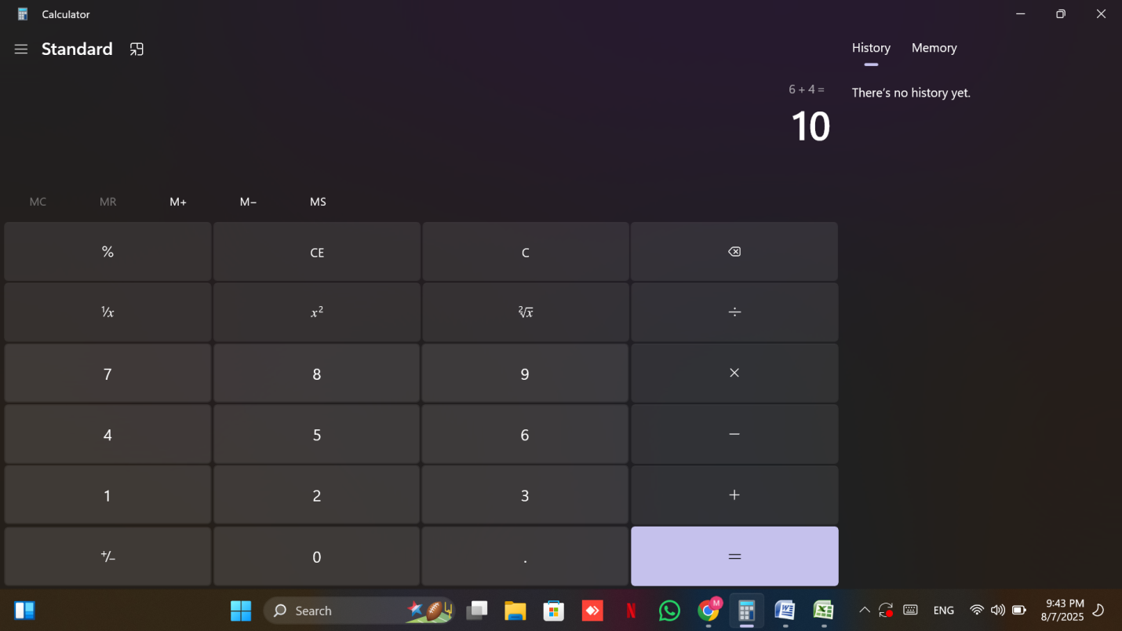

Scenario ID:2

Scenario: Subtraction

Test step:

1. Enter first number.
2. Subtract second number.
3. Click on =.

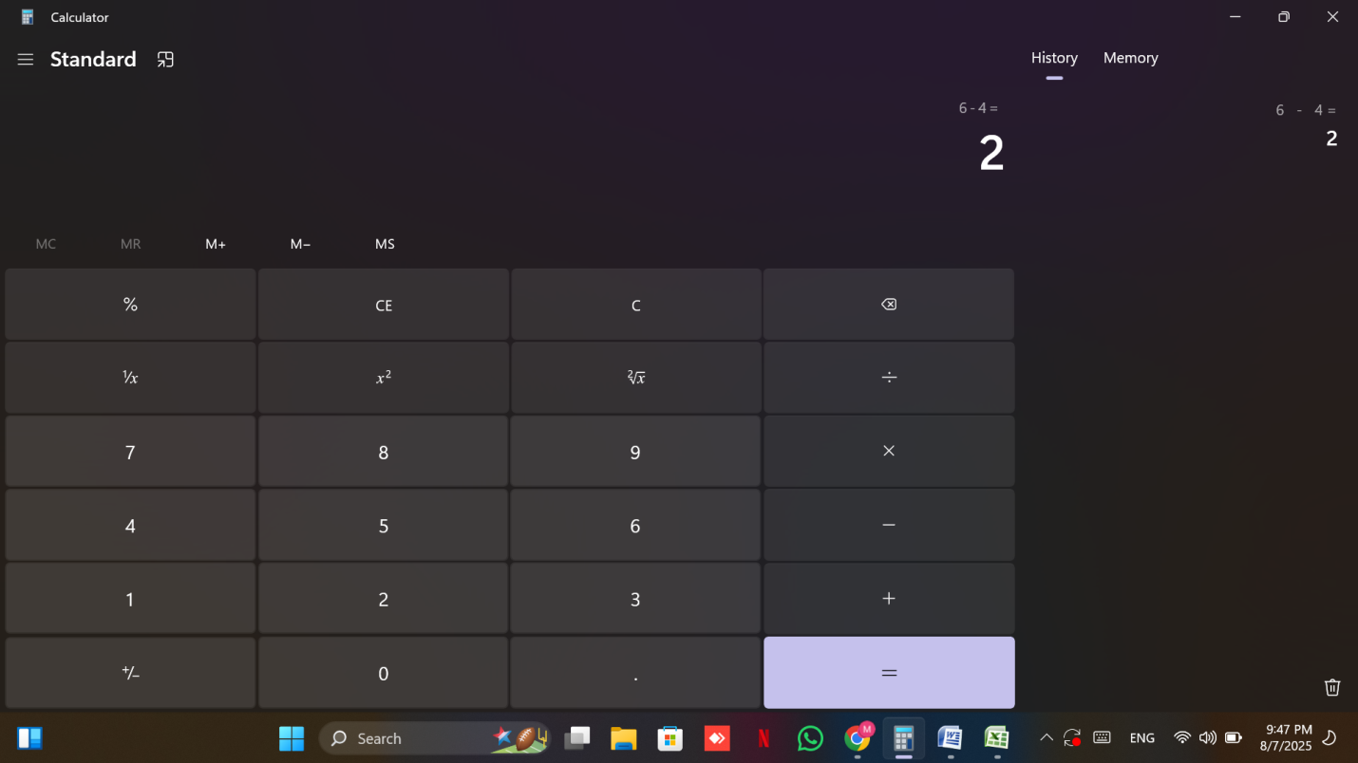

Scenario ID: 3

Scenario: Multiplication

Test step:

1. Enter first number.
2. Multiply second number.
3. Click on =.

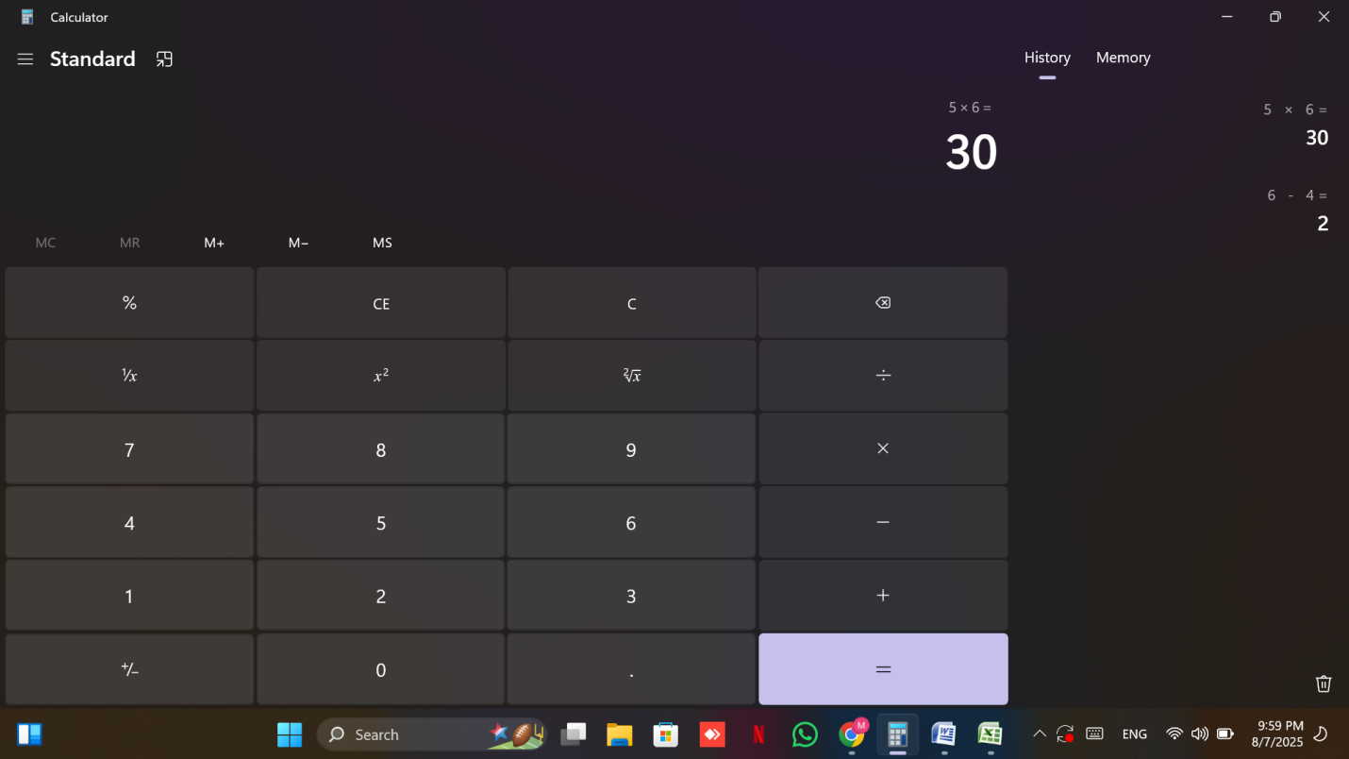

Scenario ID: 4

Scenario: Division

Test step:

1. Enter first number.
2. Divide second number.
3. Click on =.

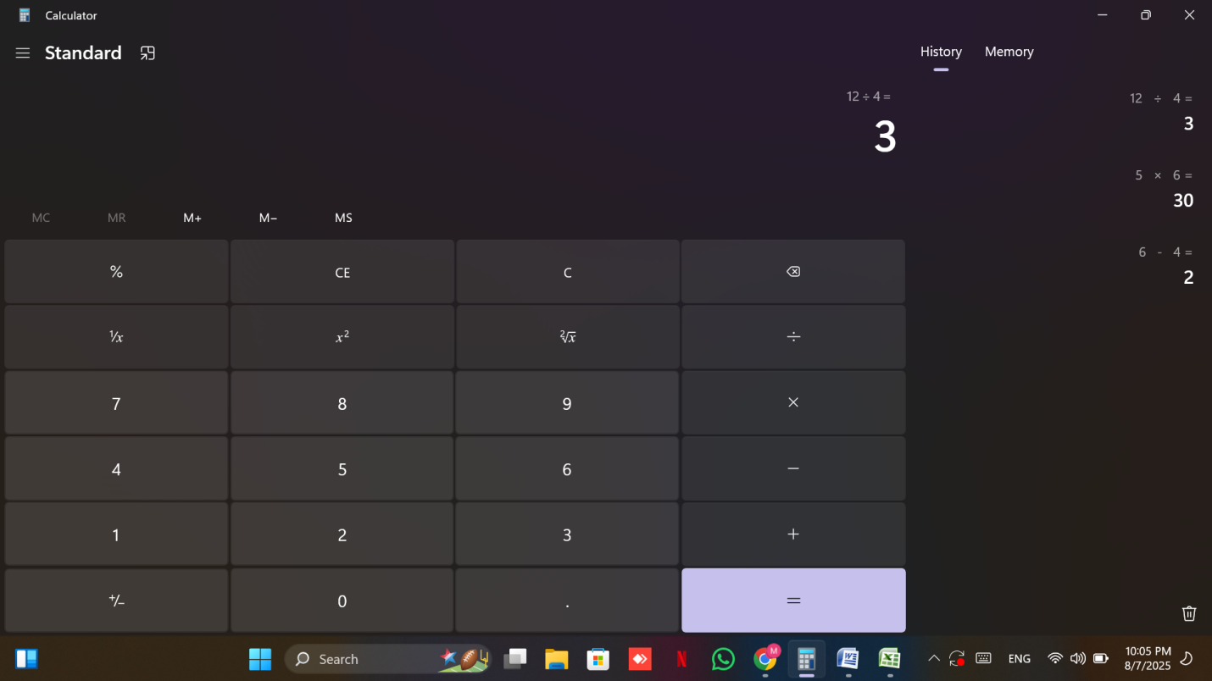

Scenario ID: 5

Scenario: Division by zero

Test step:

1. Enter first number.
2. Divide by 0
3. Click on =.

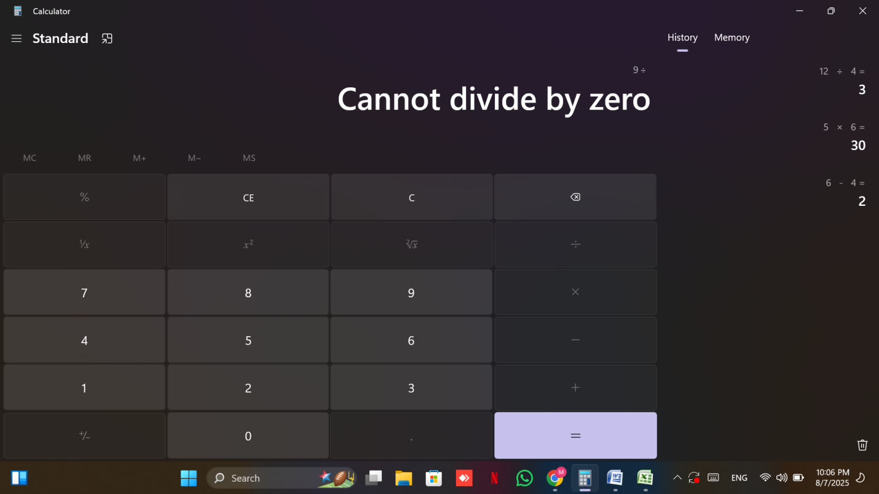

Scenario ID: 6

Scenario: Decimal Addition

Test step:

1. Enter decimal number
2. Add decimal number.
3. Click on =.

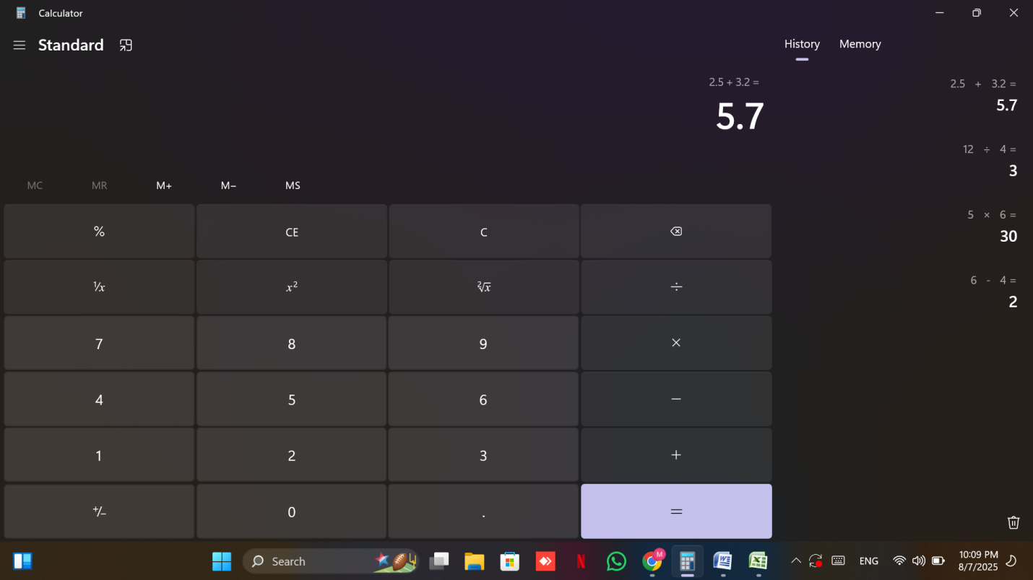

Scenario ID: 7

Scenario: Input: Multiple Operations

Test step:

1. Add two number
2. And multiply one number wit it
3. Click on =.

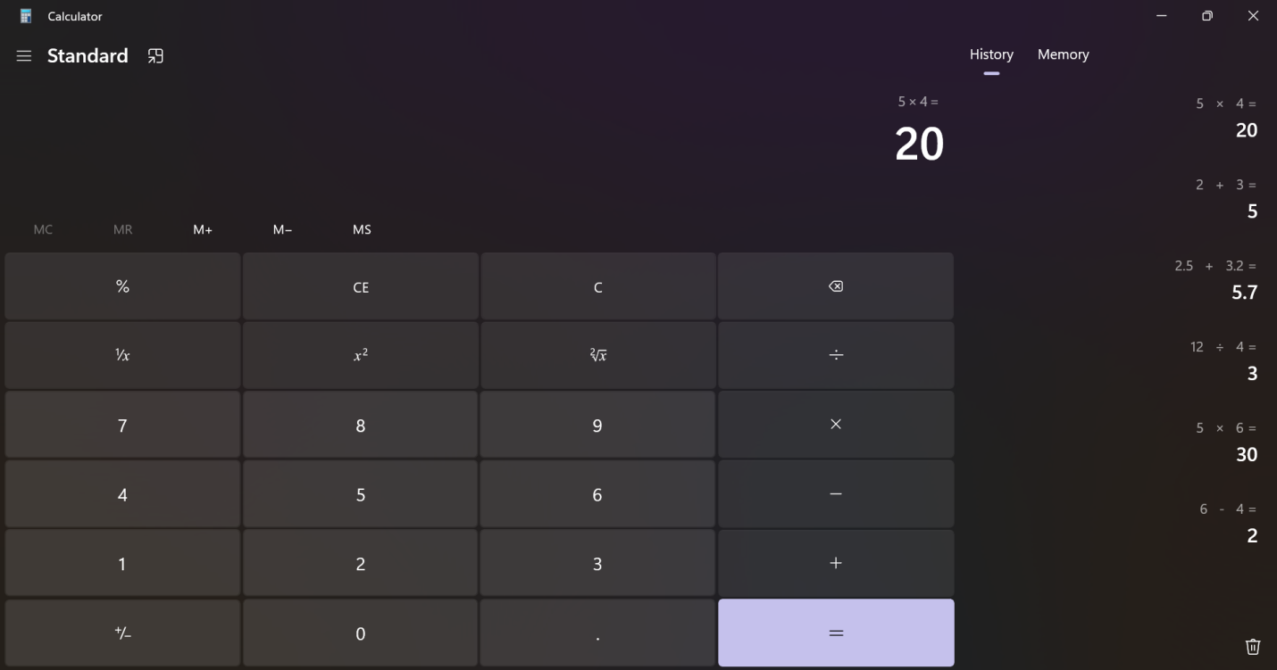

Scenario ID: 8

Scenario: Use of Clear (C/AC) Button

Test step:

1. Add two number
2. Click C/CE

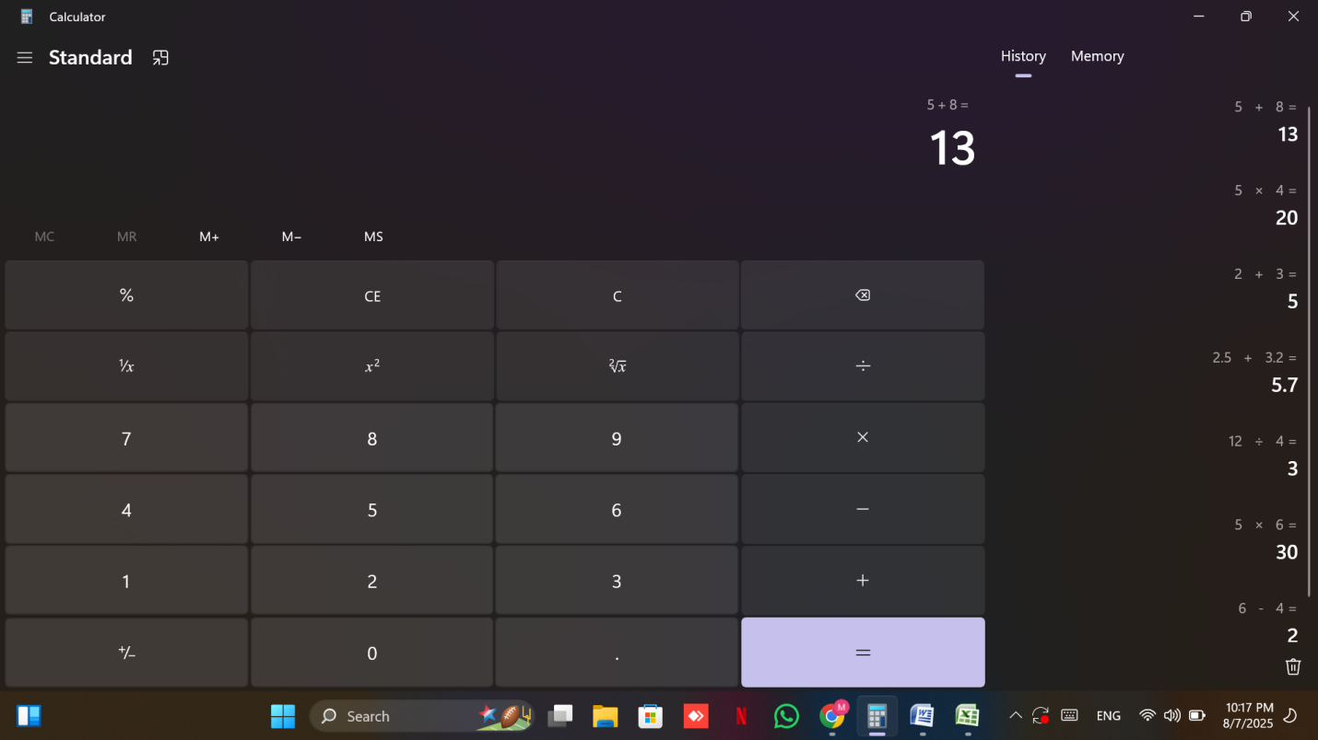

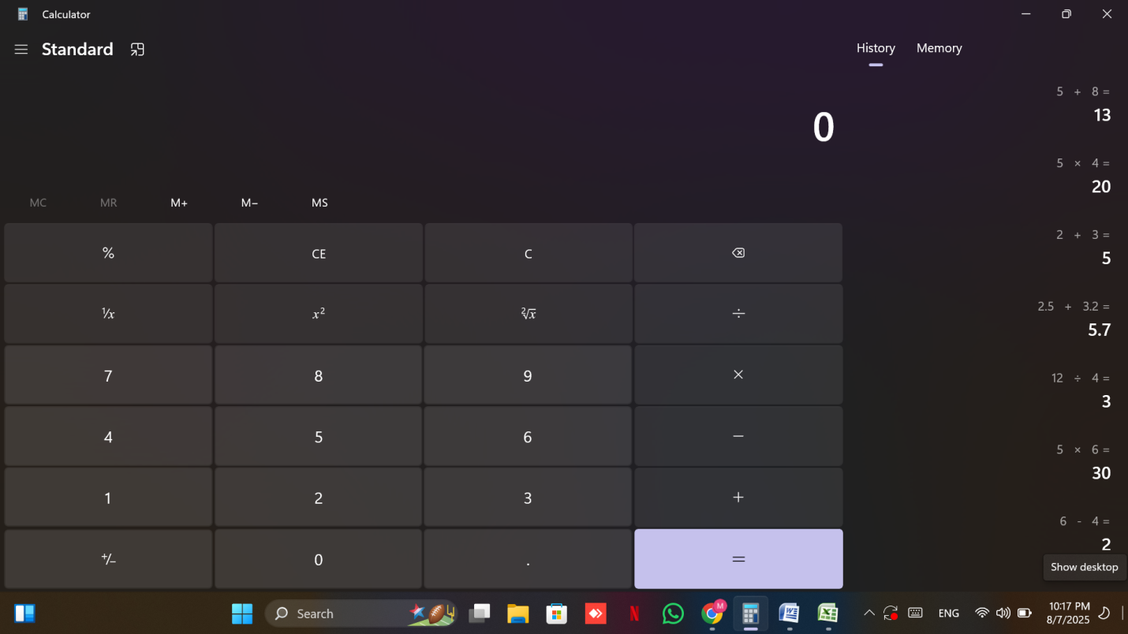

Scenario ID: 9

Scenario: Input Error Handling

Test step:

1. Enter any arithmetic operator.
2. Click on =.

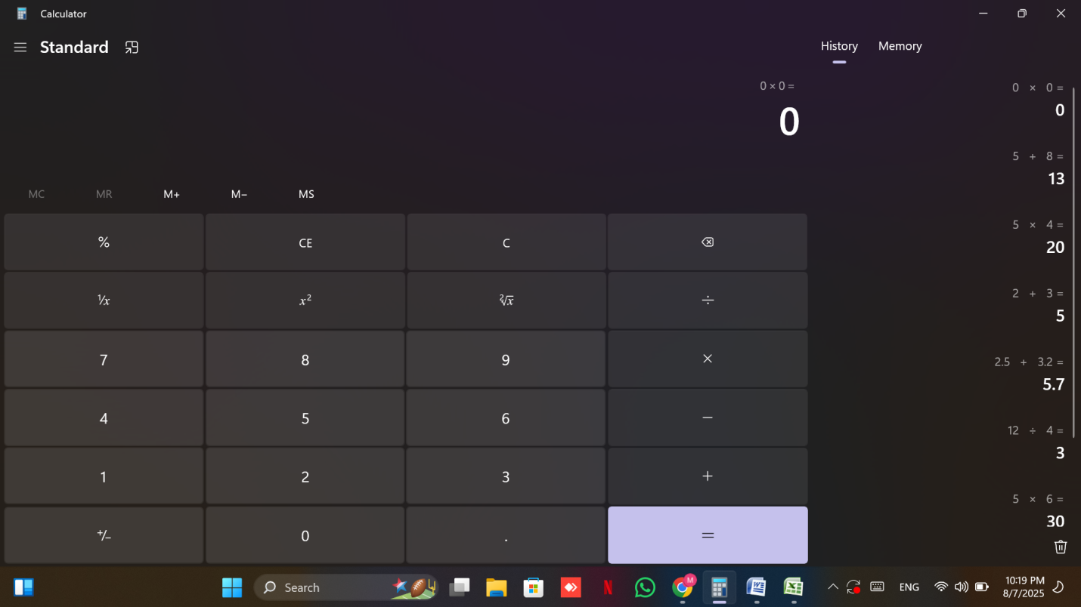

* **Summary Of Test Results:**

**Total Test Cases-** 9

**Passed-** 7

**Failed-** 2

**Pass %- 77.78%**

* **Bug Reports:**

**1.**

| **Field** | **Description** |
| --- | --- |
| **Bug ID** | BUG-1 |
| **Title** | Not according to BODMAS |
| **Module** | Standard Calculator |
| **Severity** | High |
| **Steps to Reproduce** | 1. Add two number(2+3)  2. And multiply one number wit it (2+3x4)  3. Click on =. |
| **Expected Result** | 14 |
| **Actual Result** | 20 |

**2.**

| **Field** | **Description** |
| --- | --- |
| **Bug ID** | BUG-2 |
| **Title** | No error is displayed |
| **Module** | Standard calculator |
| **Severity** | Medium |
| **Steps to Reproduce** | 1. Enter any arithmetic operator. (+=)  3. Click on =. |
| **Expected Result** | Error |
| **Actual Result** | 0+0=0 |

9.  **Conclusion and Recommendations**

* Pass Rate:85%, Needs Improvement
* Improve error message display for invalid inputs.